November 8, 2018 [DRAFT ONLY]

GAI Project No. A180281.00

Four Corners Area Council

Kissimmee/Osceola County Chamber of Commerce

1425 E. Vine street

Kissimmee, Florida 34744

Summary of Scope of Work for Four Corners Area Council: One Vision Program

Dear Area Council:

Based on our task authorization dated May, 2018, this letter summarizes our observations and comments related to the various tasks outlined in the Scope of Service Agreement with the UCF Florida Institute of Government. This summary tracks the various tasks, as well as additional work undertaken as a result of input from the Four Corners Area Council (Council) during the data gathering process. This additional work specifically related to providing additional meetings with the Council and preparation and presentation to the Four Corners Area Council: One Vision Summit, which were not contemplated in the original scope.

Our work and the survey effort was prepared in close concert with the Council, with regular monthly meetings beginning in June through the October Summit. In addition to the independent meetings held with the respective county staffs, the key event was the September 6, 2018, half-day stakeholder workshop.

Task 1 Data Gathering and Overview

The initial task included the delineation of area to be studied. This effort included meeting with members of the Council as well as input from respective four county planning staffs. It also included review of the previous Four Corners studies in 2002 and 2007. A consensus was reached to include an area of approximately 92 square miles (see attached Map 1).

This task also included review of the land use characteristics, identifying proposed developments, listing public agencies with jurisdictional responsibilities, and identifying political subdivisions. (see Chart 1).

Map1: Four Corners Area

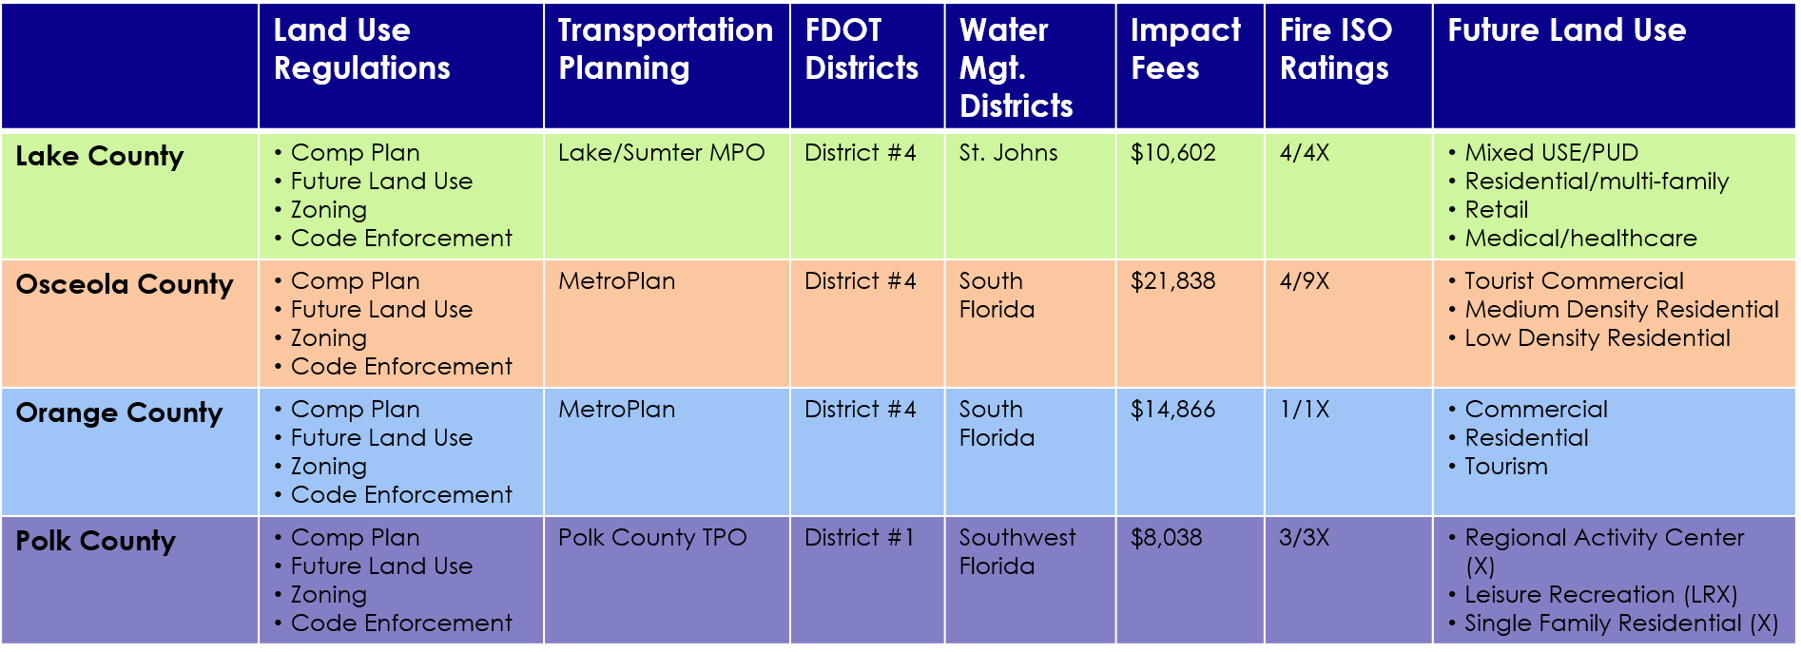

Chart 1: Four Corners Area Characteristics

Task 2 & 3 Identifying Issues and Strategies

Tasks 2 & 3 related to identifying strategies issues, areas of special importance, specific area strengths, weaknesses, as well as opportunities. Gathering this information was accomplished through a series of meetings with the Council, the various county staffs, and the half-day stakeholder workshop. The results of these inputs are summarized as follows:

* Identified Issues
  + Multi jurisdictions – political subdivisions
  + Differences in land use and zoning regulations
  + Differences in impact fee rates
  + Differences in ISO insurance ratings
  + Area not a political priority – lack of voters
  + Concern for affordable housing for employment base
  + Schools to serve the growing resident base
  + Accommodating growing traffic issues for area

In addition to the issues identifies above, the workshop highlighted the strong desire to create an organizational structure to oversee future Four Corners development and advocacy. The type of entity was described as having the following responsibilities:

* + Regulatory consistency
  + Corridor upgrades
  + Sustainable economic development
  + Coordinated transportation response
  + Public safety
  + Affordable housing for employment base
  + Promotion and marketing of area as destination
  + Advocate for 92 square mile area
  + Understanding there are distinct issues depending on location within area

The remaining tasks in the scope related to keeping the Council regularly informed on the fact gathering and observation process, which was done through the monthly meetings, as well as preparation for the Summit (see attached PowerPoint).

Implications and Interpretation.

Based on the input and recommendations from all involved, the Council is now in a position to determine the next steps. As indicated by panelists’ and participants’ comments at the Summit workshop, there appears to be a very strong consensus to move forward with the establishing a steering committee to determine the type of entity to implement the findings, and to provide input to early staff level coordination among the four counties.

Recommendations.

*Recommendation 1* -- The Four Corners Council should convene and establish a Steering Committee to oversee Phase 2 of the Four Corners One Vision process. The Steering Committee should have representation from the public and private sectors.

*Recommendation 1* -- Phase 2 of Four Corners One Vision should focus on developing a structure and funding model for a continuing entity tasked with promoting collaboration among public and private stakeholders in the Four Corners area, and on initiating cooperation between the four counties on issues that can be addressed in the short term, particularly regulatory consistency in land use, zoning and Land Development regulations.

*Recommendation 3* -- The Steering Committee should work with a technical committee consisting of staff from the Four Corners counties to develop the shorter term measures addressing regulatory consistency in the areas of land use, zoning and LDRs.

Sincerely, Sincerely,

Thomas R. Kohler Rafael Montalvo